For Immediate Release

Construction Begins for Jefferson Oaks, a New Mixed-Income Community that will Bring High-Quality, Affordable Homes for Families and Individuals in the Region

- Innovative $17.6 million adaptive reuse of the Thomas Jefferson School building and campus will provide 60 new homes when completed in 2018

- UnitedHealthcare is the largest investor, providing $14.6 million through partnership with Cinnaire

Oak Park, Mich. (June 27, 2017) – Community leaders and development partners came together today to celebrate the start of construction for Jefferson Oaks, a new 60-unit mixed-income community designed of high-quality residential homes, which will be built and maintained to be appealing and affordable for hard-working families and individuals.

Developed by Community Housing Network (CHN), the new community is being built on the site of the vacant Thomas Jefferson School building and campus, which will be transformed into 20 apartments and eight new townhome-style buildings with an additional 40 homes. In total, the new community will include 9 one-bedroom apartments, 11 two-bedroom apartments, 24 three-bedroom townhomes and 16 four-bedroom townhomes. Twenty-one of the units are set aside for supportive housing.

“We are very excited to start the construction of this new community in Oak Park and appreciate all the partners involved in helping make this groundbreaking possible,” said Marc Craig, president of Community Housing Network. “When completed next year, Jefferson Oaks will be a model community that brings quality homes with on-site amenities for individuals and families who want a wonderful place to live and play.”

Jefferson Oaks will feature on-site amenities for residents, including a community room with a library, computer lab and meeting space, and a playground. There will also be controlled entry and security features, along with 120 off-street, surface parking spaces.

"This is an important moment for our community as we work together to bring new, quality homes for individuals and families in Oak Park," said Marian McClellan, mayor of Oak Park. “With the support of so many partners, Jefferson Oaks is a visionary model on how we can lift up and support residents as they build their future for themselves and their families.”

Project and development partners include the City of Oak Park, Cinnaire, Community Housing Network, Huntington Bank, Michigan State Housing Development Authority (MSHDA), Minnesota Equity Fund (MEF) and UnitedHealthcare.

“Today marks an important milestone in helping create new models for quality, affordable housing in Michigan,” said Earl Poleski, executive director, MSHDA. “Jefferson Oaks will provide new hope and opportunity for the families and individuals who get to call it home.”

MSHDA approved the use of Low Income Housing Tax Credits for Jefferson Oaks with Cinnaire and its strategic partner MEF securing $14.6 million in equity funding from UnitedHealthcare, the largest investor in the new development. Cinnaire is also providing a $2.3 million loan, with CHN providing $692,000 through multiple fundraising resources for the $17.6 million development. Construction financing was secured through Huntington Bank.

“UnitedHealthcare’s investment in Jefferson Oaks is part of a company initiative to help people live healthier lives by connecting quality and affordable housing to better health,” said Dennis Mouras, CEO, UnitedHealthcare Community Plan of Michigan, which employs 1,100 people in Michigan and serves the health care needs of more than 800,000 residents in the state. “We are grateful for the opportunity to work together to help expand housing opportunities for the residents of Southeast Michigan.”

UnitedHealthcare has invested $34.8 million to help build four affordable housing communities in Michigan through its partnership with Cinnaire and MEF.

“Cinnaire partners with socially motivated companies like UnitedHealthcare to make economic investments in well-designed, high-quality affordable-housing developments,” said Mark McDaniel, president and CEO of Cinnaire. “This investment will help meet a critical need in Michigan and we are proud to be a partner and help break ground on such an important housing community in Oak Park.”

“At Huntington Bank affordable housing is a priority. Our family of bankers believe it is our responsibility to not only provide the highest quality products and services in the communities we serve, but also to enhance the quality of life in those communities,” said David Lochner, Huntington Bank Regional President. “One of my greatest privileges as regional president for Huntington is to foster partnerships with those organizations that will change the local landscape, making affordable housing dreams come true.”

Jefferson Oaks is expected to open in the Spring of 2018. O’Brien Construction Company is managing the building and construction with Fusco, Shaffer & Pappas, Inc. as the architects. CHN will partner with Piper Management Group to provide property management and on-site supportive services. Information about rental applications and how to support the new community can be found at communityhousingnetwork.org.

# # #

KEY SPEAKERS/DIGNITARY BIOGRAPHIES
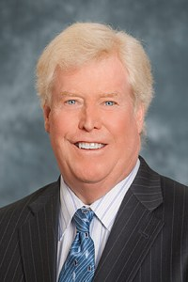
Marc Craig, President, Community Housing Network, is a passionate advocate for creating sustainable, inclusive communities, and has been involved in the affordable housing sector for more than 25 years. He is the founding president of Community Housing Network where he continues to lead. He has been proud to direct the rapid growth of the organization, from three staff members in 2001 to more than 80 staff and 133 volunteers today. At CHN, Marc leads a team that throughout the years has leveraged more than $82.4 million in resources to create and maintain the stock of affordable housing in metro Detroit, maintaining offices in Oakland, Wayne and Macomb counties.

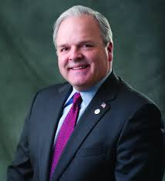
Earl Poleski was named Michigan State Housing Development Authority’s executive director on February 22, 2017. He previously served in the Michigan Legislature from 2011 to 2016, holding prominent roles as chair of the Financial Liabilities Reform Policy Committee and the General Government Appropriations Subcommittee. Earl also has been a certified public accountant since 1981, working as a sole-practitioner and partner with accounting firms providing individual and business accounting, tax and consulting services, while also representing clients to the IRS and state tax agencies.
He has also served in the oil and gas industry, where he managed the controllership, tax and treasury functions of CMS Nomeco Oil & Gas Co. in Jackson, and as vice president, treasurer and chief financial officer of Dart Energy Corporation in Mason.

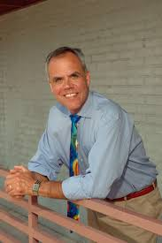
Mark McDaniel is president and CEO of Cinnaire. Through McDaniel’s leadership, Cinnaire is on the cutting edge of new approaches to low-income housing development, working collaboratively with universities, housing development authorities and the foundation community to blend housing rehabilitation with efforts to provide residents with much-needed child and family services. McDaniel received his bachelor’s degree in urban planning from Michigan State University in 1977 and has over 30 years of experience in affordable housing, community development, urban planning and market research. McDaniel also serves on the boards of more than a dozen nonprofits.
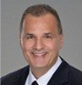
Dennis Mouras is CEO of UnitedHealthcare Community Plan of Michigan. Previously, he worked for Aetna, CareAdvantage, and held a variety of positions with Cigna Corporation. Dennis is a strategic leader with experience and exceptional skills in general management, business development, innovation, organizational transformation and achieving bottom-line results. He holds a Bachelor of Arts Degree in Economics from Kean University.

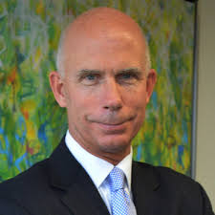
David J. Lochner is president of Huntington’s East Michigan Region. He joined Huntington in 2016 following the merger of FirstMerit into the company. While at FirstMerit, he served as president of the Michigan region. He was responsible for the bank’s commercial, industrial, commercial real estate and not-for-profit lines of business throughout the state. Lochner served as director of commercial banking for RBS Citizens in Michigan, and was a member of the bank’s Michigan Executive Leadership Group. He also was a senior vice president and commercial banking division head for LaSalle Bank Midwest. His banking career began at National Bank of Detroit, where he held various positions in corporate banking, middle market banking and commercial credit administration.

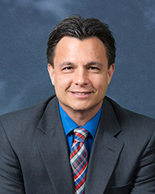
Kevin Yee is assistant City Manager for the City of Oak Park. During his nearly 18 years working for Oak Park he has held various management positions including director of Public Works and City Engineer. He received his B.S. in Civil Engineering at Michigan State University and an MBA from Walsh College of Accountancy and Business Administration.

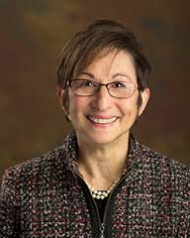
Marian McClellan, Mayor, City of Oak Park was first elected to the City Council in 2011. She has been a resident of Oak Park since 1990 with lives with her spouse, Keith McClellan. She is a retired teacher that served in Detroit, Warren, Rochester Hills, and Ferndale for 32 years.

